H.T No
Regulations:
A17

Sreenidhi Institute of Science and Technology
(An Autonomous Institution)
Code No: 6F302 Date: 06-Mar-2023 (FN)

B.Tech II-Year I- Semester External Examination, February/March-2023 (Supplementary)
Mathematical Foundations of Computer Science (CSE & IT)

Time: 3 Hours Max.Marks:75
Note: a) No additional answer sheets will be provided.
b) All sub-parts of a question must be answered at one place only, otherwise it will not be valued.
c) Missing data can be assumed suitably.

Bloom's Cognitive Levels of Learning (BCLL)

Remember | L1 | Apply | L3 | Evaluate | L5
Understand | L2 | Analyze | L4 | Create | L6

Part - A Max.Marks:25

Answer all QUESTIONS.
 |  | BCLL | CO(s) | Marks
1 | Define well formed formula. Is the expression (~P->Q -> R) a well formed formula? | L1 | CO1 | [2M]
2 | Define Homogeneous Solution and Particular Solutions. | L1 | CO2 | [2M]
3 | Write the properties of Lattice. | L1 | CO3 | [2M]
4 | Define an Abelian Group. | L1 | CO4 | [2M]
5 | Define multigraph. Give an example | L1 | CO5 | [2M]
6 | Write conditions for stating two graphs are isomorphic. | L1 | CO6 | [3M]
7 | Define disjunctive syllogism and Modus Ponens. | L1 | CO1 | [3M]
8 | Define POSet. Give an example. | L1 | CO3 | [3M]
9 | State the Lagrange’s Theorem. | L1 | CO4 | [3M]
10 | Write the differences between Euler Graph and Hamiltonian Graph. | L1 | CO6 | [3M]

Part – B Max.Marks:50
ANSWER ANY FIVE QUESTIONS. EACH QUESTION CARRIES 10 MARKS.

 |  |  | BCLL | CO(s) | Marks
11. | a) | Using Truth Tables, show that ∼(P → Q ) → (∼Q) is a tautology. | L1 | CO1 | [5M]
 | b) | Obtain the Principal Disjunctive normal form for the  Expression (P ↔ Q) ∧ (∼P → R) | L2 | CO1 | [5M]
12. | a) | Symbolize the following argument and check for its validity using Predicate Calculus:  All lions are dangerous animals  There are lions  Therefore, there are dangerous animals. | L2 | CO2 | [5M]
 | b) | Solve the recurrence relation an =an-1 +an-2,n≥ 2, given  a0 =1,a1 =1 using substitution method. | L3 | CO2 | [5M]
13. | a) | Construct a relation Matrix for the following graph.  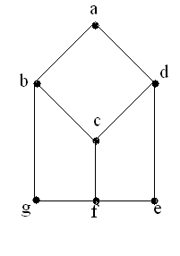 | L6 | CO3 | [5M]
 | b) | A relation R is defined over set of all integers as aR b⇔ b=ar for some positive integers. Show that the relation R is a partial ordering relation. | L1 | CO3 | [5M]
14. | a) | Define Semi group. Verify which of the following are semi groups.  i. (N, +), ii. (Q, -), iii. (R, +) iv. (Q,o),aob=a-b+ab. | L2 | CO4 | [5M]
 | b) | Show that the set of all positive rational numbers forms a group under the composition * defined by  a * b = (ab)/2 . | L1 | CO4 | [5M]
15. | a) | Prove that the given two graphs are isomorphic graphs.  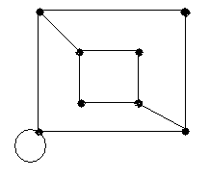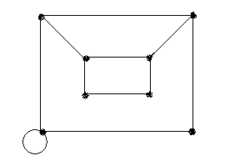 | L3 | CO5 | [5M]
 | b) | Define Depth first search and Breadth first search and a spanning tree. Explain through example. | L2 | CO5 | [5M]
16. | a) | Prove that the chromatic number of a tree on n vertices is 2. | L3 | CO6 | [5M]
 | b) | What is the number of vertices in an undirected connected graph with 27 edges, 6 vertices of degree 2, 3 vertices of degree 4 and remaining vertices of degree 3? | L1 | CO6 | [5M]
17. | a) | Write antecedent and consequent rules of Automata Theorem Proving. | L1 | CO1 | [4M]
 | b) | Define particular Solution of recurrence relation. | L1 | CO2 | [3M]
 | c) | Let X={2,3,6,12,24,36}. Draw the Hasse diagram for the POSet [ X ; ]. (Note:| Stand for division) | L2 | CO3 | [3M]
18. | a) | In a group (G, *) , Prove that (a*b)-1 = b-1 *a-1 for all a, b∈ G. | L3 | CO4 | [4M]
 | b) | Define Directed Trees. Give an example. | L1 | CO5 | [3M]
 | c) | How many ways can 10 similar balls be placed in six numbered boxes?. | L1 | CO6 | [3M]

-- 00 -- 00 –

